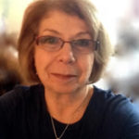 Judith Buder Zucker

I have always been artistic, creative and had an eye for graphic designing, but I didn’t begin painting until I retired from my various positions in the field of Education.
Since then, painting has become my passion. In New York, I study at the 92nd Street Y. I have also travelled to Pinzolo, Italy and Florence, Italy to study watercolor, and I am planning to take an artist’s residency in Ireland in the early Fall. Watercolor was my first medium, and I have now branched out into colored pencils and oils. My work has been selected many times to hang in the Juried Student Art Shows at the 92nd Street Y, and at the Vintage Artists Gallery Exhibits. Recently I had my own exhibit at Gallery 18 in the Riverdale Y.

